भारत मौसम विज्ञान विभाग |  | India Meteorological Department
Sunday, 01st June 2025 (11 Jyeshtha 1947 Saka)
Summary of observations recorded at 0830 hours IST: The Northern Limit of Monsoon continues to pass through 17.0°N/55°E, 17.5°N/60°E, 18°N/65°E, 18.5°N/70°E, Mumbai, Ahilyanagar, Adilabad, Bhawanipatna, Puri, Sandhead Island, 23.5°N/89.5°E, Balurghat, 30°N/85°E. The Western Disturbance as a cyclonic circulation over north Pakistan & neighbourhood lay over north Pakistan & adjoining Jammu and north Punjab of today morning. It then persisted over the same region at 3.1 km above m. s. l. with a trough aloft in middle & upper tropospheric levels with its axis at 5.8 km above m. s. l. roughly along Long. 74°E to the north of Lat. 32°N. The upper air cyclonic circulation over central Pakistan persisted at 1.5 km above m. s. l. The upper air cyclonic circulation lay over Haryana of today morning. It then persisted over the same region at 0.9 km above m. s. l. The trough ran from central Pakistan to cyclonic circulation over Haryana across north Rajasthan of today morning. It then persisted over the same region at 0.9 km above m. s. l. The upper air cyclonic circulation lay over northeast Assam at 0.9 km above m. s. l. It then persisted over the same region. A trough at mean sea level ran from central parts of east Uttar Pradesh to Arunachal Pradesh across central parts of Bihar, sub-Himalayan West Bengal, central parts of Assam. A north-south trough ran roughly along Long. 90°E to the north of Lat. 20°N at 1.5 km above m. s. l. The trough from northeast Uttar Pradesh to east Vidarbha became less marked. The upper air cyclonic circulation over northeast Arunachal Pradesh which extended upto 3.1 km above m. s. l. became less marked.
Day temperatures were markedly above normal (> 5.1°C) at isolated places over west Uttar Pradesh and Punjab. appreciably above normal (3.1°C to 5.0°C) at isolated places over sub Himalayan West Bengal & Sikkim, east Uttar Pradesh, Himachal Pradesh and east Madhya Pradesh. above normal (1.6°C to 3.0°C) at few places over Uttarakhand; at isolated places over Andaman & Nicobar Islands, Assam & Meghalaya, Gangetic West Bengal, Bihar, west Rajasthan and Tamil Nadu, Puducherry & Karaikal. near normal (-1.5°C to 1.5°C) at many places over Nagaland, Manipur, Mizoram & Tripura, Haryana-Chandigarh-Delhi and Konkan & Goa; at most places over Saurashtra & Kutch, coastal Karnataka and Lakshadweep; at few places over Odisha, east Rajasthan and Gujarat region; at isolated places over west Madhya Pradesh, Madhya Maharashtra, coastal Andhra Pradesh & Yanam, Rayalaseema, north interior Karnataka, south interior Karnataka and Kerala & Mahe. Yesterday, the highest maximum temperature of 44.2°C was reported at Sri Ganganagar (west Rajasthan).
The Southwest Monsoon has been Vigorous over Assam & Meghalaya, Nagaland-Manipur-Mizoram-Tripura and It has been subdued over Konkan & Goa, north interior Karnataka and south interior Karnataka.
Total 309 Station reported rainfall today. Total rainfall is 203.6 cm. Total 297 Station reported rainfall today whose normals are available. Total rainfall is 193.3 cm with normal station total is 112.5 cm.
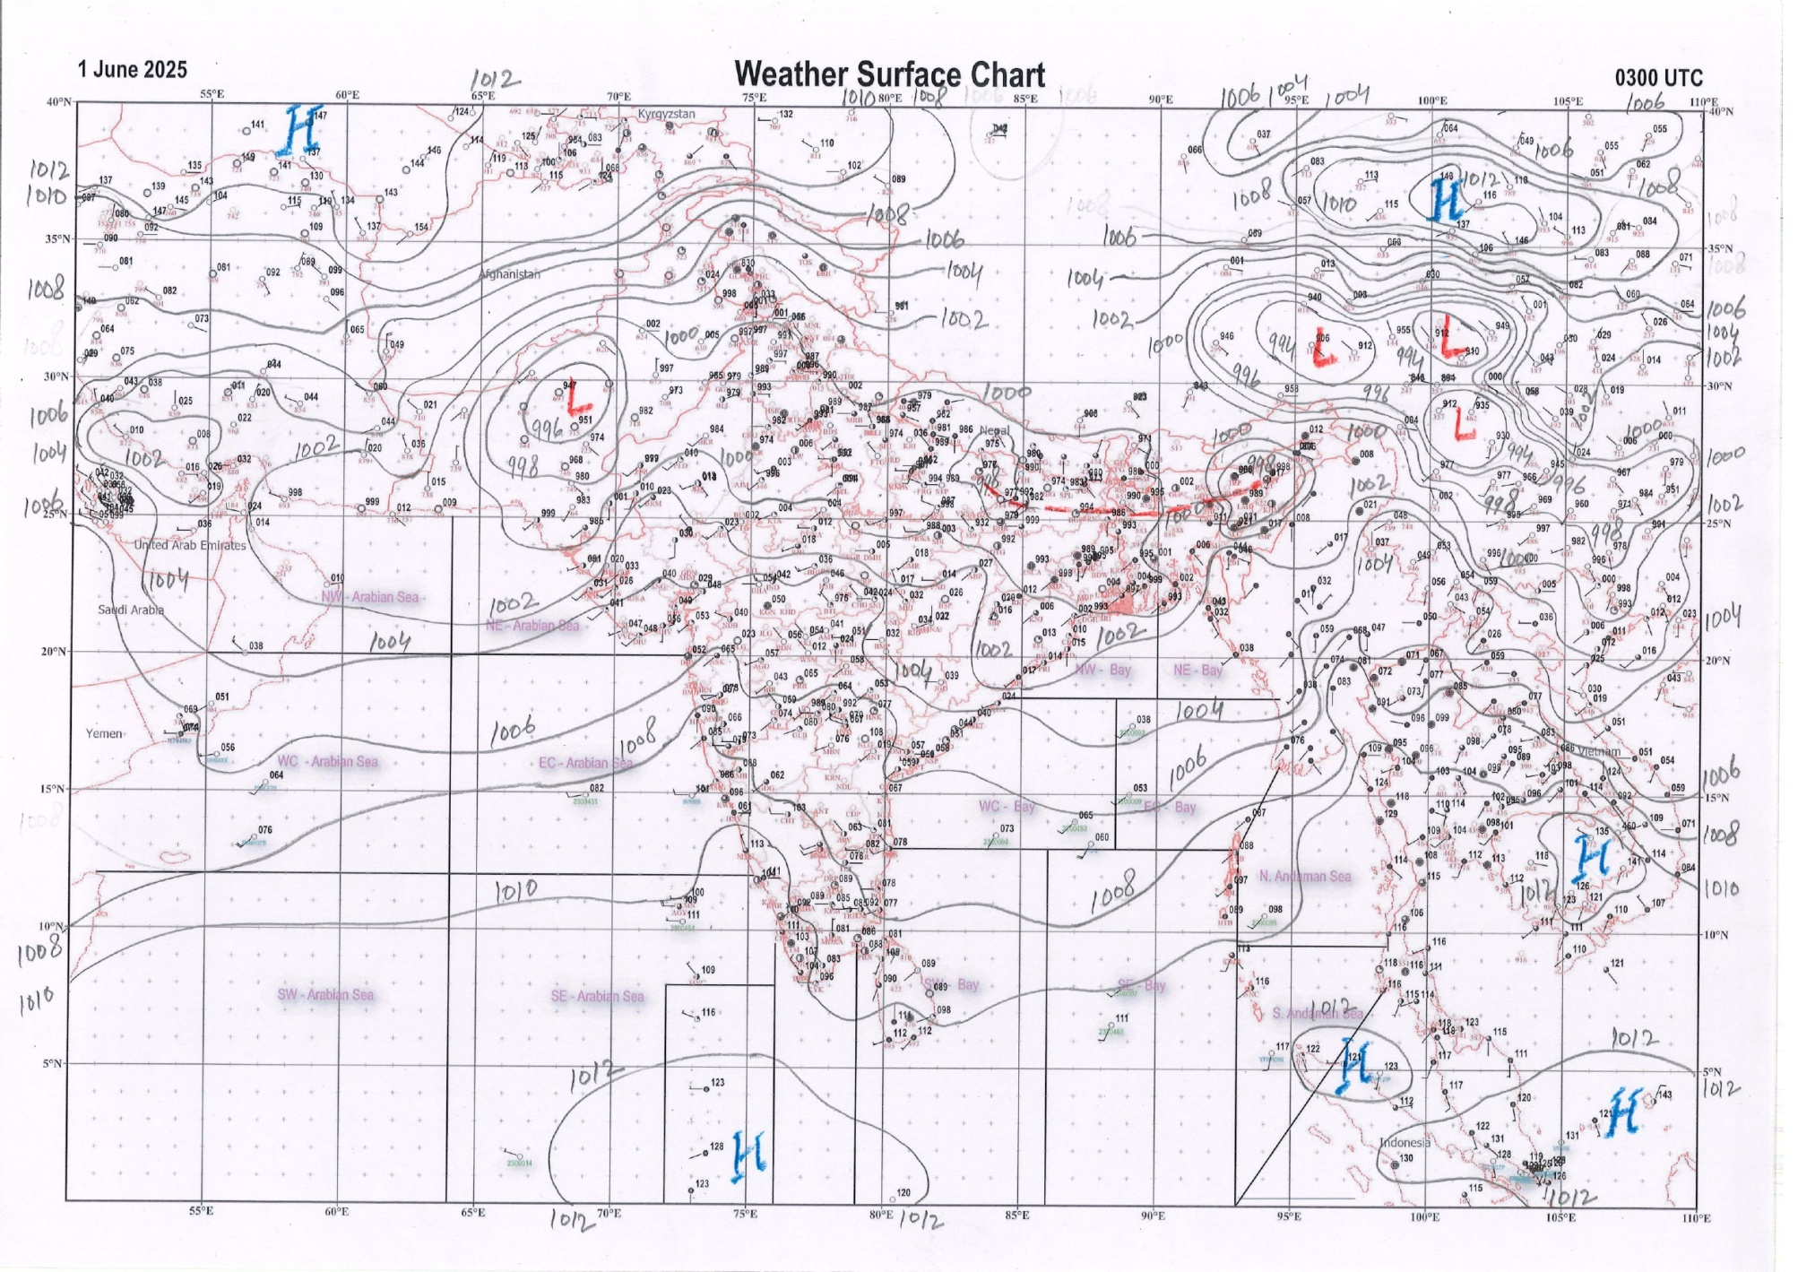 | 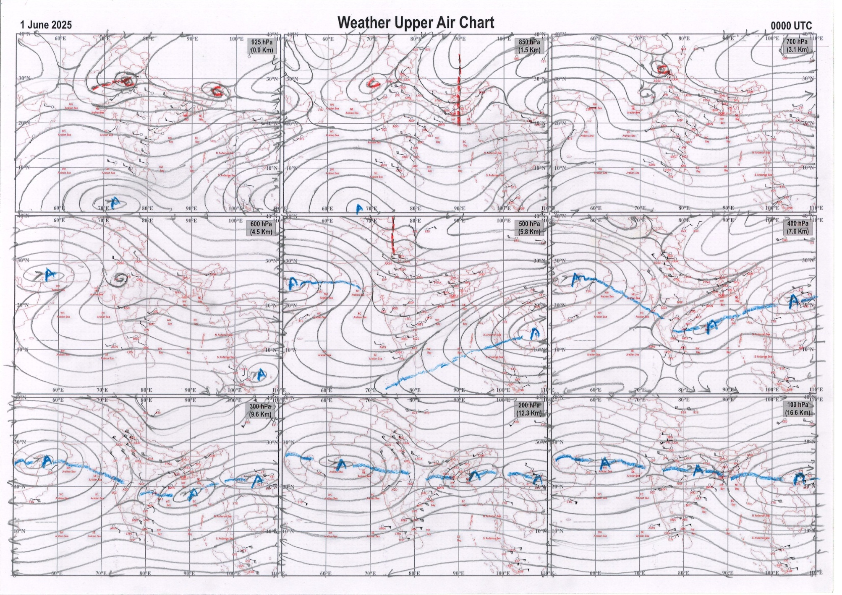
g.1. Analysed surface chart based on 03z observation | Fig.2. Analysed upper air chart based on 00z observation

Dr. Sudeep Kumar B.L.
Scientist ‘D’
CR & S Office, Pune  Issued at 1245 hrs. IST |  | Weather Forecasting Division  CR&S, Pune

Indian regions | Realised rainfall (chief amount in cm during past 24 hrs):
East | most places: Arunachal Pradesh+, Assam & Meghalaya#, Nagaland-Manipur-Mizoram-Tripura+++ and Sub-Himalayan West Bengal & Sikkim+  a few places: Odisha+  isolated places: Gangetic West Bengal, Jharkhand and Bihar  Silchar 41.6, Karimganj 35.5, A p ghat 31.9, Budhjongnagar ARG 19.9, Kailashahar AP 19.2, Arundhutinagar 18.6, Bhutanghat 11.0, Newlands tea garden & Biridi 9.4 each, Pasighat AP 6.6, Roing 6.3, Miao 5.9, Bamra 4.3, Sundargarh 3.9, Cooch behar & Kusheswarstan 3.7 each, Bokhara 3.3, Pto tarakeswar & Nawadih 2.7 each, Supaul 2.3, Rajmahal 1.9, Kalaikunda (IAF) 1.5, Dum dum 0.9, Jamshedpur AP 0.5.
North | most places: Jammu-Kashmir and Ladakh  isolated places: Uttar Pradesh, Uttarakhand, Haryana, Punjab, Himachal Pradesh and Rajasthan  Pahalgam 3.7, Manjhanpur 3.5, Banihal & Larnoo ARG 3.4 each, Patiala 2.9, Patiala AWS 2.6, Hissar & Nagina REV 2.5 each, Bara & Mukerian 1.5 each, Bharmaur 1.3, Chandigarh & Paonta 1.2 each, Agra , Shikohabad, Deoprayag & Kaman 1.0 each, Kathumer 0.8, Ladnoo 0.7, Bah 0.6, Prayagraj PBO 0.5, Tehri (CWC) & Nahan 0.3 each, Dholpur tehsil SR 0.2.
Central | a few places: Chhattisgarh  isolated places: Madhya Pradesh and Vidarbha  Korba 6.1, Poudi uparora 6.0, Jaitpur 4.5, Naigarhi 3.8, Pendra road 2.8, Ater 1.7, Baihar 1.4, Porsa 1.0, Gadchiroli 0.4, Bhind-aws & Chamorshi 0.1 each.
Peninsula | most places: coastal Karnataka  many places: Kerala+  a few places: Konkan & Goa  isolated places: Gujarat Region, Madhya Maharashtra, Marathwada◆, coastal Andhra Pradesh, Telangana, Tamil Nadu and interior Karnataka  dry weather: Saurashtra & Kutch and Rayalaseema  Kayamkulam 6.7, Mancompu 5.7, Ichchapuram & Denkada 4.2 each, Castle rock 4.1, Bantwal 3.9, Agumbe emo 2.5, Wyra kvk (agro) 2.3, Nalumukku & Mangaluru AP 1.6 each, Karipur ap. 1.5, Oothu 1.2, Kudal, Matheran, Roha & Shahuwadi 1.0 each, Valparai PTO 0.8, Mahabaleshwar 0.7, Londa 0.6, Kammardi 0.5, Dhansura & Bhagamandala 0.3 each, Gandhinagar, Chandgad, Kinwat & Banswada (ARG) 0.2 each, Bhiloda & Aland 0.1 each.
Islands | many places: Andaman & Nicobar  isolated places: Lakshadweep◆  Hut bay 0.9, Maya bandar & Port blair 0.5 each, Agathi & Minicoy 0.2 each.
Table 2. Forecast / warnings (distribution of rain / thundershowers) for 7 days (valid from time of origin upto 0830 hrs IST of next day)
Sr. No |  | Sub-division Name | Day 1 | Day 2 | Day 3 | Day 4 | Day 5 | Day 6 | Day 7 | Sr. No. | Sub-division Name | Day 1 | Day 2 | Day 3 | Day 4 | Day 5 | Day 6 | Day 7
 |  |  | 01 Jun | 02 Jun | 03 Jun | 04 Jun | 05 Jun | 06 Jun | 07 Jun |  |  | 01 Jun | 02 Jun | 03 Jun | 04 Jun | 05 Jun | 06 Jun | 07 Jun
 | 1 | Andaman Nicobar Islands | W  | W | F | F | W | W | W | 19 | west Madhya Pradesh | I  | I  | S  | S  | I  | I | I
 | 2 | Arunachal Pradesh | W ++  | W +  | W +  | F +  | F +  | F | F | 20 | east Madhya Pradesh | I  | I  | I  | I  | I  | I | I
 | 3 | Assam-Meghalaya | W#  | W ++  | W ++  | W +  | F +  | F | F | 21 | Gujarat region | I | I | I | I | I | I | I
 | 4 | Nagaland-Manipur-Mizoram-Tripura | W # +  | W ++  | W +  | F +  | F  | S | S | 22 | Saurashtra and Kutch | I  | I  | I | I | I | I | I
 | 5 | Sub Himalayan West Bengal/Sikkim | W ++  | W +  | F  | F | F | F | F | 23 | Konkan and Goa | F + | S | F | I | S  | I | I
 | 6 | Gangetic West Bengal | S  | I | I | S | S | I | I | 24 | Madhya Maharashtra | I | I | I | I  | I  | I | I
 | 7 | Odisha | I | I  | I  | I + | I + | I | I | 25 | Marathwada | I | I | I | I | I  | I | I
 | 8 | Jharkhand | S  | I | I | I | I | D | D | 26 | Vidarbha | I  | I  | I  | I  | I  | I | I
 | 9 | Bihar | I  | I  | I  | I  | I | D | D | 27 | Chhattisgarh | I  | I  | I  | I  | I  | I | I
 | 10 | east Uttar Pradesh | I | I | I  | I | I | D | D | 28 | Coastal Andhra Pradesh and Yanam | I  | I  | I  | I  | I | I | I
 | 11 | west Uttar Pradesh | S  | S  | S  | I | I | D | D | 29 | Telangana | I  | I  | I  | I  | I  | I | I
 | 12 | Uttarakhand | F +  | F +  | F +  | S +  | S  | I | I | 30 | Rayalaseema | I  | I  | I  | I  | I | I | I
 | 13 | Haryana,Chandigarh and Delhi | S  | S  | F +  | D | D | D | D | 31 | Tamil Nadu, Puducherry and Karaikal | I  | I  | I | I | I | I | I
 | 14 | Punjab | S  | S  | S +  | D | D | D | D | 32 | Coastal Karnataka | W +  | W | W  | F  | S | S | S
 | 15 | Himachal Pradesh | S  | S  | F  | F  | S  | I | I | 33 | North interior Karnataka | I | I | I | I  | I  | I | I
 | 16 | Jammu-Kashmir and Ladakh | S  | S  | F  | S | I | D | D | 34 | South interior Karnataka | I | I | I | I  | I  | I | I
 | 17 | west Rajasthan | I | I  | I  | I  | I  | I | I | 35 | Kerala and Mahe | F +  | F + | F + | F + | S | S | S
 | 18 | east Rajasthan | I  | I  | I  | I  | I  | I | I | 36 | Lakshadweep | F  | F | F | F | S | S | S
Legends: D = Dry I = Isolated S = Scattered F = Fairly widespread W = Widespread # = heavy to very heavy rain at a few places with extremely heavy rain at isolated places +++= heavy rain at a few places with very heavy rain at Isolated places ++= heavy to very heavy rainfall @=Isolated exceptionally heavy rainfall + = heavy rain ●/*= rain or snow ♦ = very light rain ≡ =fog = thunderstorm with lightning =Squall / Gusty / gale / strong wind ­ =cold wave/cold day += heat wave/warm night/hot and humid weather =Duststorm =ground frost = Hail
Fig. 4: Districtwise warnings for five days for Maharashtra State
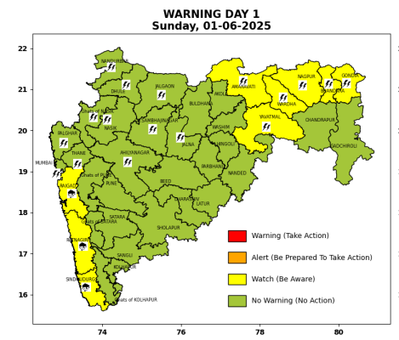 | 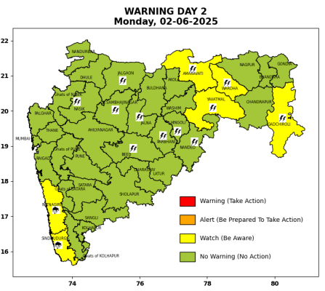 | 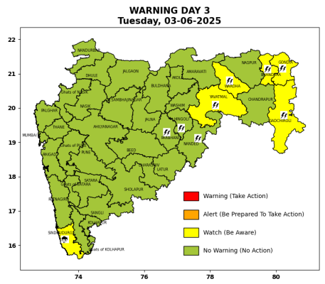 | 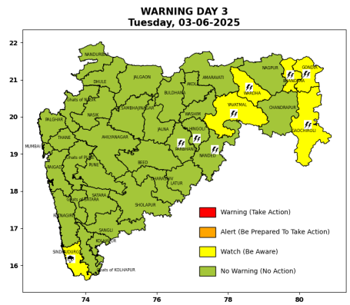 | 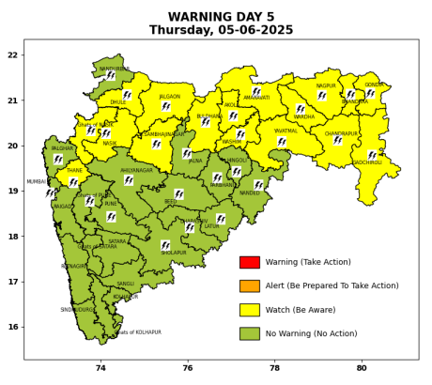

Pune, Lohegaon and Pashan observations at 0830 hrs. IST of Today
 | Temperature (°C) |  |  |  |  | Humidity (%) |  |  |  | Rainfall (mm)
 | Max.  past  24 hrs | Dep.  from  normal | Min.  past  24 hrs. | Dep.  from  normal | Dry  Bulb | At 0830 hrs. IST | Dep.  From  normal | At 1730  hrs. IST of y’day | Dep.  from  normal | Past  24 hrs. | Since  1st June | Dep.  from  normal
PNE | 32.4 | -3.3 | 22.6 | -1.0 | 26.8 | 76 | 7 | 56 | 5 | 0.0 | 0.0 | -3.7
PSN | 32.0 | - | 21.3 | - | 26.2 | 79 | - | 62 | - | 0.0 | 0.0 | -
LHG | 34.7 | 0.7 | 25.3 | 4.3 | 28.8 | 58 | -11 | 43 | -8 | 0.0 | 0.0 | -4.7

 |  |  |  |  |  |  | Local (Pune and neighbourhood) forecast
Max. / Min. Temperature (°C) |  |  |  |  |  |  |  |  | Weather
Date | Pune | Pashan | Lohegaon | Chinchwad | Lavale | Magarpatta | NDA | Koregoan Park
01/06/25 | 30 / 22.6* | 30 / 21.3* | 32 / 25.3* | 29 / 24.1* | 28 / 22.8* | 31 / 25.3* | 29 / 24.1* | 30 / 24.6* | Partly cloudy sky becoming generally cloudy sky towards afternoon/evening. Very light to light rain likely.
02/06/25 | 31 / 22 | 21 / 21 | 34 / 24 | 31 / 23 | 29 / 23 | 32 / 24 | 30 / 23 | 32 / 24 | Partly cloudy sky becoming generally cloudy sky towards afternoon/evening. Very light to light rain likely.
03/06/25 | 32 / 22 | 32 / 21 | 34 / 24 | 32 / 23 | 30 / 23 | 33 / 24 | 31 / 23 | 33 / 24 | Partly cloudy sky becoming generally cloudy sky towards afternoon/evening. Very light to light rain likely.
04/06/25 | 32 / 23 | 32 / 22 | 34 / 25 | 32 / 24 | 30 / 24 | 33 / 25 | 31 / 24 | 33 / 25 | Partly cloudy sky becoming generally cloudy sky towards afternoon/evening. Very light to light rain likely.
05/06/25 | 32 / 23 | 32 / 22 | 34 / 25 | 32 / 24 | 30 / 24 | 33 / 25 | 31 / 24 | 33 / 25 | Partly cloudy sky becoming generally cloudy sky towards afternoon/evening. Very light to light rain likely.
06/06/25 | 33 / 24 | 33 / 23 | 35 / 26 | 33 / 25 | 31 / 25 | 34 / 26 | 32 / 25 | 34 / 26 | Partly cloudy sky becoming generally cloudy sky towards afternoon/evening. Very light to light rain likely.
07/06/25 | 33 / 24 | 33 / 23 | 35 / 26 | 33 / 25 | 31 / 25 | 34 / 26 | 32 / 25 | 34 / 26 | Partly cloudy sky becoming generally cloudy sky towards afternoon/evening. Very light to light rain likely.
Rainfall Distribution |  |  | Rainfall Categories | Rainfall (mm) |  | Cloud condition |  |  |  | Rainfall Intensity |  | Range
Widespread (W) | 76-100% |  | Very Light rain | Trace to 2.4 mm |  | Mainly clear sky |  | 1-2 oktas |  | Light Spell |  | 1 cm/hr
 |  |  | Light rain | 2.5 to 15.5 mm |  | Partly cloudy sky |  | 3-4 oktas |  | Moderate Spell |  | 1-2 cm/hr
Fairly Widespread (FW) | 51 – 75% |  | Moderate rain | 15.6 to 64.4 mm |  | Generally cloudy sky |  | 5-7 oktas |  | Intense Spell |  | 2-3 cm/hr
Scattered (S) | 26 – 50% |  | Heavy rain | 64.5 to 115.5 mm |  | Overcast |  | 8 oktas |  | Very Intense Spell |  | 3-5 cm/hr
isolated (I) | 1 – 25% |  | Very heavy rain | 115.6 to 204.4 mm |  |  |  |  |  | Extremely Intense Spell |  | 5-10 cm/hr
D (D) | No Rain |  | Extremely heavy rain | ≥ 204.5 mm |  |  |  |  |  | Cloudburst |  | > 10 cm/hr
Probability Terms in %: |  |  | Heavy snow | 6.5 to 11.5 cms water equivalent of rain
unlikely | < 25 |  | Very heavy snow | 11.6 to 20.4 cms water equivalent of rain
likely | between 25 50
very likely | between 51 75
most likely | >75
* = realized temperature
Mumbai (Colaba) |  |  |  | Nagpur (AP)
Date 2025 | T max °C | T min °C | Weather | T max °C | T min °C | Weather
01/06 | 33 | 26 | Generally cloudy sky with light rain. | 38 | 26 | Partly cloudy sky towards afternoon or evening.
02/06 | 32 | 27 | Generally cloudy sky with light rain. | 38 | 26 | Partly cloudy sky towards afternoon or evening.
03/06 | 32 | 27 | Generally cloudy sky with Light Rain or Drizzle. | 38 | 26 | Generally cloudy sky towards afternoon or evening. Thunderstorm accompanied with lightning & gusty winds(40-50kmph).
04/06 | 33 | 27 | Generally cloudy sky with Light Rain or Drizzle. | 38 | 26 | Generally cloudy sky towards afternoon or evening. Thunderstorm accompanied with lightning & gusty winds(40-50kmph).
05/06 | 33 | 26 | Partly cloudy sky with one or two spells of rain or thundershowers. | 38 | 26 | Thunderstorm accompanied with lightning & gusty winds(40-50kmph).
06/06 | 33 | 26 | Rain. | 37 | 26 | Partly cloudy sky.
07/06 | 32 | 26 | Rain. | 37 | 26 | Partly cloudy sky.

